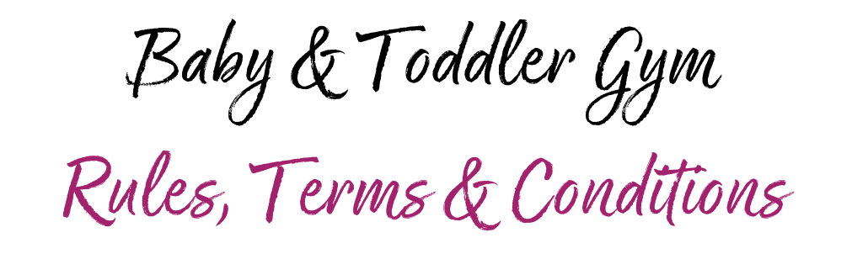

Our customers’ wellbeing and safety is our top priority so to keep our customers as safe as possible, we have introduced a number of new measures. By booking onto / attending our Baby & Toddler Gym session(s) you agree to the terms and conditions set out below.

You must not attend any of our sessions if you, someone you live with, or if someone within your support bubble is showing symptoms of Coronavirus, has tested positive for Coronavirus, or if you have been told to self-isolate by NHS Test and Trace. Anyone displaying symptoms will not be allowed into the Gymnastics Centre and will be required to leave immediately. Please follow NHS and Government guidance, and if required, get yourself tested. If you receive a positive test and have recently visited the Centre, you must inform the Club ASAP by emailing: gym@southdurhamgym.co.uk. You should also not attend any sessions if you have recently returned from a country which requires a period of self-isolation upon return. You will be permitted to return once you have completed the necessary self-isolation period.

BOOK YOUR VISIT ONLINE
- Sessions are suitable for children aged 9 months - 4 years and cost £6 per child. Siblings under 9 months can come along for free - but must be carried in a sling where possible
- Online bookings must be made & paid for in advance before you enter our Baby & Toddler Gym session: https://www.southdurhamgym.co.uk/product/baby-toddler-gym/
- This system will facilitate the NHS Test and Trace system – for further details, please see section 10 of our Privacy Policy: https://www.southdurhamgym.co.uk/page/privacy-policy/
- All bookings are non-refundable and non-transferrable

REDUCED CAPACITY & SESSION SIZES
- To facilitate social distancing, all Baby & Toddler Gym sessions will be limited to a maximum of 30 children
- To further assist with social distancing, only 1 adult per child will be permitted into the session
- Parents/guardians are required to accompany their children around the Centre to facilitate social distancing

ACCESS TO THE PINK GYM
- Access to the Gymnastics Centre will now be via the fire door behind the Grand Electric Hall; customers will need to queue up the ramp to the Centre, adhering to social distancing guidelines. Please note that you will not be able to access the Gymnastics Centre via the main Leisure Centre entrance
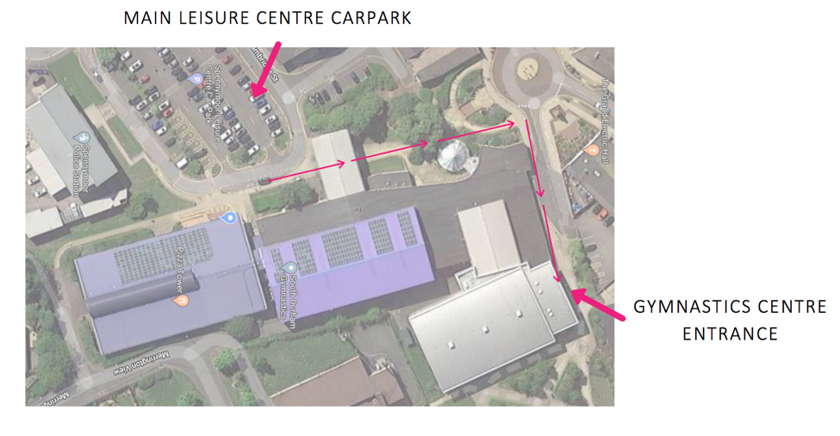
- Please have a copy of your email confirmation ready for entry
- We also ask that you arrive & leave on time to allow us to be ready for the next play session
- 10 minutes prior to your session start time, a member of Team Pink will invite you into the building, at which point each person entering the building (children & adults) will have their temperature checked
- Please adhere to social distancing guidelines and one-way systems when you enter the building
- No pushchairs or prams are allowed in the gym – they must remain in the corridor (please note there will be reduced space for buggies / prams in the corridor to allow for social distancing, so they may need folding to allow for appropriate storage)

SOCIAL DISTANCING
- Customers must adhere to social distancing rules and remain at least 2 metres apart from others at all times
- Parents/Guardians are wholly responsible for their child(ren) whilst in the Gymnastics Centre

FACE COVERINGS
- It is mandatory for our visitors to wear face coverings
- Adult customers and children aged 11 and over will be required to wear a face covering before entering and keep it on until they leave (except when eating & drinking)
- Customers must provide their own face coverings
- Failure to comply may result in entry being refused or being asked to leave the Centre, please don’t be offended if we ask for evidence of exemption

TEMPERATURE CHECKS
- Before gaining entry to the Gymnastics Centre, all customers (adults & children) will be temperature checked
- If your temperature is above 37.8 degrees, you will be asked to wait a couple of minutes before trying again, if it remains over 37.8 degrees you will be asked to leave, and we will contact you to rearrange your visit

SANITISING STATIONS
- Customers must sanitise their hands upon arrival at the Gymnastics Centre, we thank you for your cooperation with this
- We also have a number of sanitising stations around Gymnastics Hall for customers to use throughout their visit

STORAGE OF PERSONAL BELONGINGS
- No outdoor footwear is permitted within the Gymnastics Hall
- Personal belongings can be stored in the wooden duckets within the Gymnastics Hall
- Please keep your personal belongings safe; South Durham Gymnastics do not accept responsibility for the loss or damage to any personal belongings left unattended on the premises

FOOD & DRINK
- No food/drink is permitted in the gym unless in spill proof beakers beside the wooden duckets
- Breastfeeding is allowed within the gym

TOILET FACILITIES
- The toilet inside of the Gymnastics Centre, as well as the Accessible Toilet (with baby changing station) remain open as normal – operating a 1 in 1 out process
- Both of our Male and Female toilets and changing facilities are currently closed
- All parents/guardians will be required to fully supervise their child(ren) when visiting the toilet. Hand washing signs are in place to remind our guests of the hand washing procedures required

CLEANING MEASURES
- We have a number of additional cleaning measures in place to ensure your safety
- Full cleaning of the facility will take place on a daily basis with high touch point areas being cleaned hourly
- Equipment (obstacle course, slides, hard toys etc.) will be cleaned between each Baby & Toddler Gym session
- Cleaning equipment will be available for parents/guardians upon request, should they chose to sanitise an area before their child(ren) play on it

SAFE & RESPECTFUL USE OF THE GYMNASTICS CENTRE
- Please ensure your child plays with toys/equipment suitable for their age
- Parents/guardians are responsible for ensuring no intentional damage is caused to our building and its contents
- All visitors using the equipment will be responsible/liable for any damage or injury occurring from or as a result of misuse or reckless use
- Siblings aged 7+ that attend during the school holidays must attend in a support capacity only – they MUST NOT climb/jump/swing on any of the equipment or inflatables

PHOTOGRAPHY
- Is permitted; please be respectful to other families and try get pictures/videos containing your own child(ren) only

VIEWING GALLERY & SD DINER
- Will remain closed throughout Baby & Toddler Gym sessions

PLAY AREAS & ACTIVITIES
- Parents/guardians are responsible for their own child(ren) and they play at their own risk
- Children must not push, collide, fight, throw, run or behave in a manner likely to injury or cause distress to others
- To be COVID secure we are not permitted to use the (foam) pits; we request all parents/guardians are vigilant with this guidance. Mats are placed in the foam pits where possible to create soft ‘landing areas’
- All ‘soft’ toys have been removed, so only equipment / toys that have hard surfaces (that can be wiped clean) will be in use
- The Challenger will not be in use as we resume Baby & Toddler Gym sessions

Trampolines
- Only one child per trampoline
- Mats must remain on the trampolines at all times
- Parents can gently jump on a trampoline holding their babies
- Please refrain from using the trampolines if you are within the first 3 months of pregnancy, or 6 months after giving birth
- Do not attempt somersaults on the trampoline as this may result in serious injury

Air Track (long, bouncy inflatable)
- Is suitable for children only
- Adults are not permitted on the Air Track, unless it is to help their child to get off

ZERO TOLERANCE POLICY
All of our measures are in place for the safety of our guests and staff. We are working extremely hard to ensure all measures are being carried out in line with Government, British Gymnastics & Durham County Council guidelines. Any persons not complying with the measures we have in place will either be refused entry, asked to leave and may be refused future entry. We are hoping our customers will work alongside us to help us keep our Centre operational and fight the virus.

South Durham Gymnastics has 5 COVID Officers in place; if you have any questions, concerns or feedback about our practices, do not hesitate to contact one of them:
- Melissa Spence - melissa@southdurhamgymnastics.co.uk Note: Melissa will be on maternity leave from Jan 2021
- Kelly Milnes - kelly@southdurhamgymnastics.co.uk
- Jenna Maynard - jenna@southdurhamgymnastics.co.uk
- Helen Maxwell - helen@southdurhamgymnastics.co.uk
- Becca Armstrong - becca@southdurhamgymnastics.co.uk

PLEASE NOTE: WHILST WE HAVE TRIED TO MAKE YOUR VISIT WITH US AS SAFE AS POSSIBLE, YOU ENTER AND USE OUR FACILITIES AT YOUR OWN RISK.

